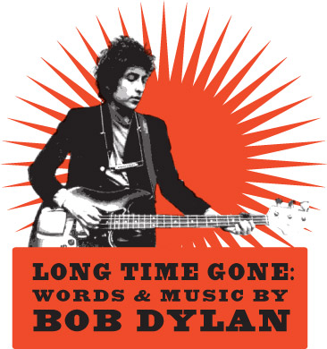
Theater, Art & Entertainment, Music
Press contact: Victoria O’Brien
860.916.4749
victoriatobrien@gmail.com

Long Time Gone: Words & Music by Bob Dylan
Selected & Performed by Peter Landecker
with Guy Davis and BettySoo

Performances 8PM January18 - February10, 2013
Lyric Hall, 827 Whalley Avenue, New Haven, CT.
Jan 18 – Benefit Preview for Neighborhood Music School Jan 19 - Benefit Preview for Jamie A. Hulley Arts Foundation
Jan. 23 - Benefit Preview for Habitat for Humanity of Greater New Haven
Jan. 24 - Opening Night Benefit for Lyric Hall with reception
Performances Thurs-Sun Jan 25,26,27,31, Feb.1,2,3,7,8,9,10
Tickets $35. students, seniors, $25. (not for benefit previews & opening night, must bring photo id), Opening Night Jan. 24, $45.
Purchase online at www.lyrichallnewhaven.com or by telephone: 1-800-514-ETIX (3849), ex.1
Long Time Gone, a theatrical biography, tells the story of one of the most intriguing and influential figures ever, entirely through his words and music. At intimate & historic, Lyric Hall, blues master Guy Davis & acclaimed singer-songwriter, BettySoo will perform the songs in personal interpretations. Between the songs, Peter Landecker as Dylan speaks to the audience & re-creates interviews, one in each act.
The story is of a kid who leaves home in Minnesota at 18 and is worldwide star by the age of 21, whose songs define the times during enormous social change. No sooner, he upturns all the norms of popular music giving us incandescent poetry in song. His fresh take on everything is ahead of his time. Act One ends with “Like a Rolling Stone”.
Act Two reveals Dylan wanting no part of being spokesman of a generation, he speaks of family life and influences. The songs are country & reflect a man in love. A dream sequence becomes “All Along the Watchtower”. The heartbreak songs lead to redemption & the act two interview delves into spirituality but he says it’s the songs nourish him. “Forever Young” leads to a verse from the title song performed in act one. He’s singing to his Ma, “I’m a long time comin’ and I’ll be a long time gone.”
"An Audience Grabber!" (Variety)﻿
"Dylan remains incandescent and starkly relevant in this lovingly conceived tribute." (The Live Music Report, Toronto)
"Peter Landecker was unbelievably uncanny, he had that Dylan way about him where you didn't entirely know what direction he was going to go in with his voice but it always turned out to be the right direction." (Burlington Free Press, VT)
"Powerful, beautiful, and enigmatic." (The Record, Sherbrooke, Québec)
"Guy Davis is one of the best bluesman in circulation. Writing of him and his music, the New York Times used words like "talent, charisma and authority" and Living Blues has talked of "impeccable craftsmanship" and "lyrical vision." The magazine "Mojo" said that "today nobody knows how to mix the thousand aspects of Afro-American music such as Guy Davis."
"BettySoo’s voice is the perfect combination of strength, vulnerability and clarity. It is just perfect." (Americana-UK)
Guy Davis is from New York City, www.guydavis.com
BettySoo is from Austin, Texas, www.bettysoo.com
BUY TICKETS at www.lyrichallnewhaven.com
or by Telephone: 1-800-514-ETIX (3849), ex.1
###

